Python Sample program execution

1. Start IDLE



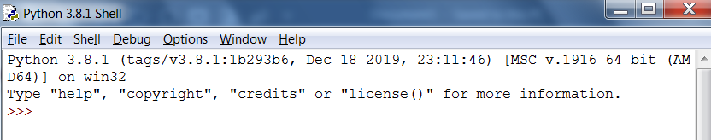

1. Open File

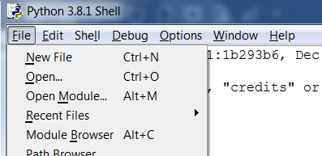

1. Open server file

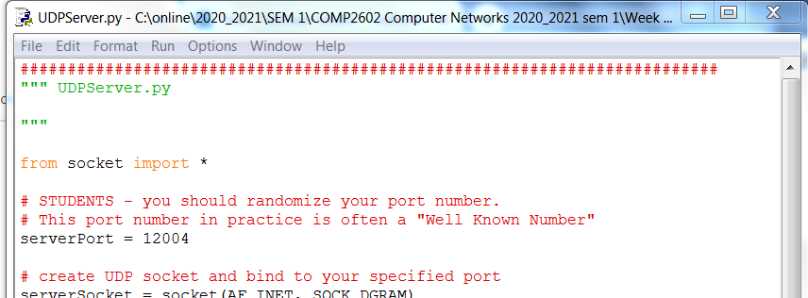

1. Run the server file



1. Server running:

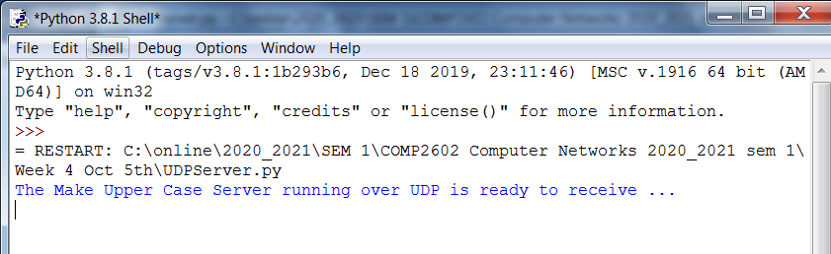

1. Open new IDLE instance



1. Open client

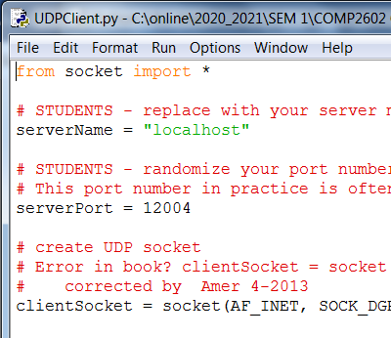

1. Run client



1. Test

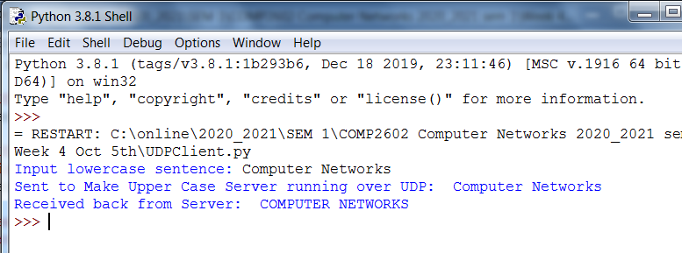

**End of Manual**